**Cataract Whole Perioperative Team Development Group**

**Summary and Recommendations**

Contents

Background 2

Purpose 2

Wider Engagement 3

Summary of feedback 3

Recommendations 4

Suggested Responsibility for Recommendations 5

Appendices 6

# Background

Cataract surgery is the most successful operation delivered across NHS Scotland, with a high success rate, low morbidity and low mortality. Demand is rising, due to the ageing of the population. In 2021, Scottish Government commissioned CfSD to address the current challenges in cataract surgery and in January 2022, the multi-professional Scottish National Cataract SLWG was established. High volume cataract surgery – at least one cataract every 30 minutes-has been recommended by multiple reports and organisations (RCOpth The Way Forward 2017, RCOpth High Flow Cataract Surgery 2021, GIRFT programme National Specialty Report in Ophthalmology 2019).

The SLWG has produced a Cataract Blueprint to assist Health Boards to deliver high volume cataract surgery across Scotland. A Cataract Sub-Specialty Delivery group has been developed to implement the recommendations from the Blueprint. This delivery group has a number of sub-groups, one of which has produced a Toolkit to further support Health Boards with this process.

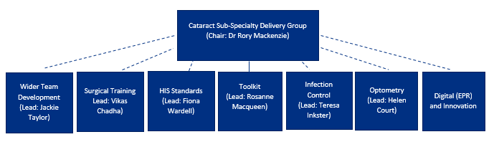

# Purpose

TheCataract **Whole Perioperative Team Development Group (WPTDG)** focused on enhancing the skills of the peri-operative team, to facilitate the delivery of high volume cataract surgery across Scotland.

The full Terms of Reference are attached in Appendix 1. The membership of the group was reflective of the expertise and professional requirements needed to support the remit of the group (full list in ToR).

The WPTDG agreed that the areas of focus most likely to have an impact on the delivery of high volume cataract surgery were:

* Human factors and ergonomics training
* Enhancing the skills of Band 2-4 assistant practitioners
* Advanced skills acquisition

# Wider Engagement

From centres which have successfully implemented HVCS, it is clear that the nursing team is critical to driving change. In addition to drawing on the expertise of the subgroup to formulate recommendations, a range of methods were employed to facilitate wider engagement including:

* Scoping workshops with theatre lead nurses hosted and led by NHSSA
* E-survey of theatre lead nurses by NHSSA
* Workshop at Golden Jubilee National Hospital specifically focussing on Human Factors educational requirements.

The information and feedback from this wider engagement has been instrumental in developing our recommendations.

# Summary of feedback

Some general themes emerged from the workshops:

* All participants were familiar with HVCS model, viewed it positively and found the Blueprint Toolkit to be a very useful resource. No significant resistance was evident from theatre teams
* Health Boards are all at different stages of developing HVCS. There is a wide variation in both in the workforce model and remuneration of nursing staff the capabilities expected and the identified skills needs. e.
* In addition, facilities vary considerably, impacting the ergonomics of on how HVCS models might be delivered. These factors must be considered when developing education and training resources
* All participants welcomed the development of education and training resources specific to the HVCS setting.
* Consistent feedback was received about the key benefits of maintaining a stable core cataract theatre team and of the challenges in trying to achieve this.
* Releasing staff for training is challenging when service pressures are high, so digital resources were favoured.
* There was recognition that Human Factors awareness and training will be of vital importance not only in developing the whole cataract theatre team but for all of the steps to success in the Cataract Blueprint Toolkit
* Recruitment and retention of theatre staff in all specialties is extremely challenging

# Recommendations

**Recommendation 1**.

Raise awareness of general Human Factors Ergonomics (HFE) concepts and tools that can be applied by novice users to potentially evaluate and re-design existing cataract surgery clinical work systems to optimise safety, efficiency and wellbeing. Link these to Blueprint Toolkit.

A comprehensive report on HFE and suggested curriculum for the HVCS setting sits beside these recommendations in Appendix 1 and should be read in conjunction with them

**Recommendation 2.**

Develop 3-4 digital resources for HVCS setting, mapped to Step 7 of Toolkit to provide a standardised approach. These would cover:

* Obtaining consent
* Marking, prepping and draping the eye
* Medication (eye-drop) administration

These would be hosted on the TURAS platform and would be asynchronous to suit individual learning needs.

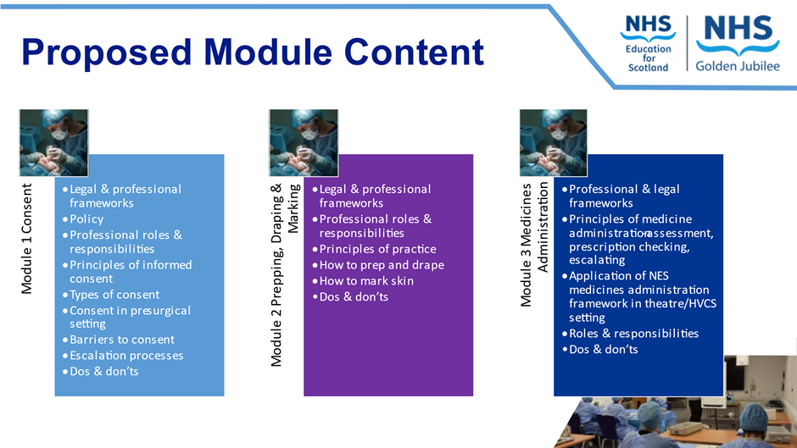

**Recommendation 3**

Develop a competency framework for application of the above procedures in practice, workplace training being essential for skills development. The framework would be developed to facilitate consistency of approach across Scotland, while allowing sufficient flexibility to be incorporated by individual Health Boards.

**Recommendation 4**

Establish a community of practice for (ophthalmology) theatre leads to facilitate sharing of knowledge and best practice and the development of educational resources and competency frameworks. Once this work is completed, it may be substituted by a peer support network, and the use of existing networks in professional organisations should be considered.

**Recommendation 5**

Develop standardised pre-operative information in a range of media: this would be of particular value in terms of training to obtain consent.

**Recommendation 6**

Increase awareness of accelerated National Perioperative Training Courses -Foundations of Perioperative Practice and Assistant Practitioners in Perioperative Practice

**Recommendation 7**

The role of Medical Associate Professions (MAPs) in HVCS setting requires further exploration.

The advantages of diversification of the workforce and development of MAP roles in a range of settings is well recognised. We are aware of MAPs performing extended roles in cataract surgery in NHSE. The training of non-medical operators may provide a bespoke solution for settings where recruitment of ophthalmologists is challenging. The Royal College of Ophthalmology and HEE are about to embark on a pilot of Physician Associates in ophthalmology services, which we should closely watch.

# Suggested Responsibility for Recommendations

This Task and Finish group reports to the Cataract Sub Specialty Delivery Group (CSSDG), which will work with other organisations to determine how the recommendations might be taken forward. The Task and Finish Group did discuss which partners might be involved and would offer the following as suggestions for further exploration.

The importance of raising awareness and understanding of HFE (Rec 1) is critical to the development of HVCS, but clearly the concepts and principles have wide applicability across a very broad range of healthcare settings and service re-designs. We suggest that NES, in particular its HFE network and CfSD would be best placed to take this important work forwards and explore how learning could be shared across sectors. The development of a suggested curriculum and signposting to existing resources (Appendix 1) are key steps in this process.

The development of digital educational resources a community of practice for theatre nurses and (Recs 2 and 4) sit well with the NHS Scotland Academy (NHSSA). A business case for the digital resources was presented to and approved by its Executive Programme Board in October 2023. The community of practice has already been established, and expertise will be drawn from this to inform the development of the resources. The NHSSA is also producing a range of promotional materials and actively engaging with Health Boards to enhance dissemination of information on its Perioperative programmes.

The development of a competency framework (Rec 3) may sit most comfortably with NES.

The development of standardised pre-operative information (Rec 5) is likely to be helpful for a number of the T and F groups and we seek the guidance of CSSDG regarding responsibility for this.

We would suggest that the MAPS commission would be best placed to monitor the emerging roles of MAPs in HVCS (Rec 7).

# Appendices

**HFE Report and Curriculum Appendix 1**



**Terms of reference Appendix 2**

